}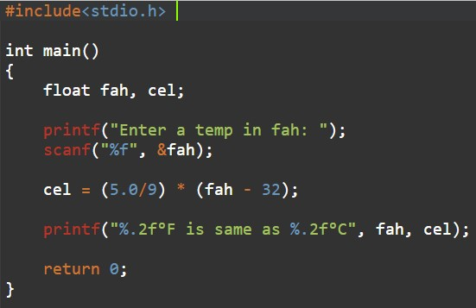

OUTPUT



HANDWRITTEN PROGRAM AS IN RECORD

